**Zentangle Reflections Art Lesson Plan**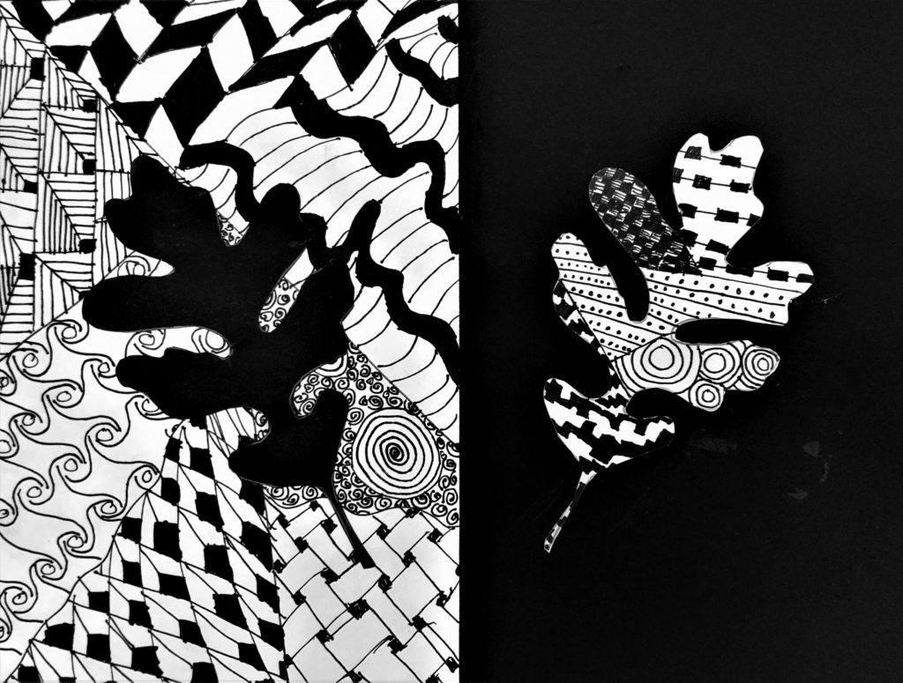

### 

### **Day 1: Introduction to Zentangle and Exploration of Line, Texture, and Patterns**

**Objective**:  
 Students will be introduced to Zentangle art, exploring the elements of line, texture, and pattern through practice.

**Materials**:

* Fine Tip Sharpie Markers
* White Construction Paper (half sheet)
* Zentangle Worksheets
* Examples of animal or leaf clipart shapes for tracing

**Instructions**:

1. **Warm-up Discussion** (15 min)  
   * Discuss students' previous experiences with doodling and Zentangle. Ask: “Do you doodle? Why? When? Where?”
   * Introduce Zentangle as a form of structured doodling for creativity and stress reduction.
2. **Defining Key Elements** (20 min)  
   * **Line**: Explain the concept of lines (horizontal, vertical, diagonal, curved, etc.).
   * **Texture**: Discuss how texture looks (tactile or visual).
   * **Pattern**: Introduce pattern as repetition and regular arrangement.
   * Discuss **Positive and Negative Space**, explaining how they work together and affect composition.
3. **Zentangle Practice** (25 min)  
   * Distribute a worksheet with various Zentangle patterns for students to practice.
   * Students practice drawing 4-5 different Zentangle patterns on their half sheet of white construction paper.
   * Encourage them to experiment with the flow of patterns and textures.
4. **Shape Selection for Final Project** (10 min)  
   * Introduce animal or leaf clipart options for students to trace. Have students pick one silhouette (e.g., owl, butterfly) to trace, cut out, and set aside for use on Day 3.

### **Day 2: Creating Zentangle Patterns on a White Sheet**

**Objective**:  
 Students will begin their Zentangle art by creating patterns on a white half sheet of construction paper.

**Materials**:

* Fine Tip Sharpie Markers
* White Construction Paper (half sheet)

**Instructions**:

1. **Recap & Review** (15 min)  
   * Briefly review the Zentangle process and how it connects to positive/negative space, line, texture, and pattern.
2. **Start Drawing Zentangle** (40 min)  
   * Students will draw 6-8 sections on their white half sheet of paper by drawing random lines across the sheet.
   * In each section, they will fill in a Zentangle pattern using only a fine-tip Sharpie marker.
   * Remind students that the patterns should be varied and can extend beyond the section boundaries for a dynamic effect.
3. **Teacher Support & Observation** (15 min)  
   * As students work, circulate around the room to help with design choices, ensure they are focusing on clean line work, and offer tips on maintaining balance between the sections.

### **Day 3: Tracing and Cutting Out the Shape**

**Objective**:  
 Students will prepare the silhouette for their final project by tracing and cutting it out.

**Materials**:

* Pre-cut silhouette shapes (animals or leaves)
* Scissors
* Black Construction Paper (9x12 sheet)

**Instructions**:

1. **Prepare Final Project Base** (10 min)  
   * Distribute a black 9x12 sheet of construction paper to each student. This will serve as the base for their final piece.
   * Review the process for cutting out shapes and ask students to trace their white silhouette onto the black construction paper.
2. **Cutting Out the Silhouette** (30 min)  
   * Students will carefully cut out the traced silhouette (animal or leaf) from the black construction paper.
   * Remind them to use precision to ensure clean edges.
3. **Placement Planning** (20 min)  
   * Students will decide where to place their silhouette on the black paper (left or right side).
   * They can experiment with different placements before gluing down.
4. **Teacher Support** (10 min)  
   * Assist students with cutting and placement decisions.

### **Day 4: Adding Zentangle Patterns to the Cut-out Shape**

**Objective**:  
 Students will add new Zentangle patterns to their cut-out silhouette.

**Materials**:

* Fine Tip Sharpie Markers
* Pre-cut silhouettes (from black construction paper)

**Instructions**:

1. **New Zentangle on Shape** (50 min)  
   * Students will now use their black cut-out silhouette as a base and fill it with new Zentangle patterns.
   * They can use different patterns than the ones on their white sheet to add variety.
   * Students should focus on maintaining contrast between the shapes and the patterns.
2. **Teacher Guidance** (10 min)  
   * Walk around and offer suggestions for balance between the silhouette and the patterns. Encourage experimentation with line thickness and texture.
3. **Finishing Touches** (10 min)  
   * Students refine their Zentangle on the silhouette, adding final details and ensuring the entire shape is filled with patterns.

### **Day 5: Final Assembly and Reflection**

**Objective**:  
 Students will assemble their Zentangle art and reflect on the process.

**Materials**:

* Glue Sticks
* Pre-prepared black 9x12 construction paper (base)
* Completed Zentangle art and cut-out shapes
* Scissors

**Instructions**:

1. **Final Assembly** (25 min)  
   * Students will glue their white half sheet Zentangle onto the black paper (left or right side).
   * They will then glue their black silhouette with the Zentangle patterns onto the opposite side of the black paper.
   * Encourage students to think about the best placement and overall composition before gluing.
2. **Gallery Walk Setup** (15 min)  
   * Once completed, allow students to walk around and observe their peers’ artwork.
   * Provide time for students to reflect on the different ways Zentangle patterns are used.
3. **Class Reflection & Discussion** (15 min)  
   * Lead a class discussion with questions like:
     + How did you use positive and negative space in your artwork?
     + What new Zentangle patterns did you discover while creating?
     + What part of the process was most challenging?
   * Discuss how line, texture, and pattern all work together to create balance and harmony in their art.
4. **Exit Reflection** (10 min)  
   * Have students complete a quick exit reflection on what they learned from the lesson and how they used mindfulness in their Zentangle designs.

**Assessment**:

* Evaluate student work on creativity, use of line, texture, and pattern, and successful integration of positive and negative space.
* Review participation in the reflection and gallery walk, considering their engagement and understanding of the concepts discussed.

